Meerut Institute OF Engineering and Technology, Meerut

Session 2023-24
Mini project report
On
“Sorting Visualizer”
BACHELOR OF TECHNOLOGY IN COMPUTER SCIENCE AND ENGINEERING (DS)
Submitted to – Mr. Mudassir
DEPARTMENT OF COMPUTER SCIENCE AND ENGINEERING (DS)
Submitted by –
Student Name- 1. Disha Bansal (2100681540017)
2. Shagun Chauhan (2100681540042)
3. Shradha (2100681540044)
5th SEMESTER
DEPARTMENT OF COMPUTER SCIENCE AND ENGINEERING (DS)
MEERUT INSTITUTE OF ENGINEERING AND TECHNOLOGY, MEERUT

Table of contents
Description Page No.
Declaration I
Certificate II
Acknowledgement III
Chapter 1 Introduction 1
Chapter 2 System Design 2
(Work flow/flowchart/DFD/ working Principle/ constructional details of individual components)
Chapter 3 Technology Bucket 3
- Description of HTML 3
- Description of CSS 4
- Description of Java Script 5
Chapter 4 Some Screens 6-8
Chapter 5 Output Screens 9-13
Appendices Implementations code
DECLARATION
We hereby declare that the project entitled - “SORTING VISUALIZER”, which is being submitted as Mini Project in Department of Computer Science and engineering (DS) to Meerut Institute of Engineering and Technology, Meerut (U.P.) is an authentic record of our genuine work done under the guidance of Prof. “Mr. Mudassir” of Computer Science and Engineering (DS)

Meerut Institute of Engineering and Technology,
Meerut.

Name of Student – DISHA BANSAL
(2100681540017)
SHAGUN CHAUHAN
(2100681540042)
SHRADHA
(2100681540044)
Date: 14/12/2023
Place: - MIET , MEERUT
CERTIFICATE
This is to certify that mini project report entitled “SORTING VISUALIZER” submitted by “DISHA BANSAL, SHAGUN CHAUHAN and SHRADHA” has been carried out under the guidance of Prof. “MR. MUDASSIR” of Computer Science and Engineering (DS), Meerut Institute of Engineering and Technology, Meerut. This project report is approved for Mini Project (KCN 554) in 5th semester in “Department of Computer Science And Engineering (DS)” from Meerut Institute of Engineering and Technology, Meerut.
Internal Examiner Date:

ACKNOWLEDGEMENT
I express my sincere indebtedness towards our guide Prof., “Mr. Mudassir” of Computer Science and Engineering (DS), Meerut Institute of Engineering and Technology, Meerut for his valuable suggestion, guidance and supervision throughout the work. Without his king patronage and guidance the project would not have taken shape. I would also like to express my gratitude and sincere regards for his kind approval of the project. Time to time counseling and advises.
I would also like to thank to our HOD Dr. (Prof.) “Mr. Rohit Aggarwal” Department of Computer Science and engineering, Meerut Institute of Engineering and Technology, Meerut for his expert advice and counseling from time to time.
I owe sincere thanks to all the faculty members in the department of Data Science for their kind guidance and encouragement time to time.

Date: Student Name: 1. DISHA BANSAL
- SHRADHA
- SHAGUN CHAUHAN

CHAPTER 1
INTRODUCTION

- We have created a visualizer project in which when user land on page for 1st time he/she will see a page where they have an options to Change an array. There is also a different buttons to Change the techniques i.e. Selection Sorting , Insertion Sort , Merge Sorting , Heap Sorting etc.

- User have to click on that button and after clicking on the button they will be see an animation of an array.
- For creating this project we uses HTML, CSS , JS.

CHAPTER 2 SYSTEM DESIGN
START

MODEL
Sorting Algorithms
`
UPDATES UPDATES
NOTIFIES

CONTROLLER
JavaScript

USER INPUT
UPDATES
VIEW
HTML User Interface

END

CHAPTER 3
TECHNOLOGY BUCKET
3. Description Html
HTML-HTML stands for Hyper Text Markup Language. It is used to design web pages using a markup language. HTML is the combination of hypertext and markup language. Hypertext defines the link between web pages. A markup language is used to define the text document within the tag which defines the structure web pages. This language is used to annotate (make notes for the computer) text so that a machine can understand it and manipulate text accordingly. Most markup languages (eg. HTML) are human-readable. The languages uses tags to define what manipulate has to be done .
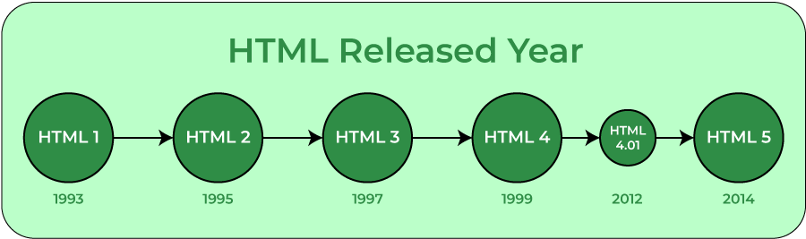

ELEMENTS AND TAGS- HTML uses predefined tags and elements which tell the browser how to properly display the content. Remember to include closing tags. If omitted, the browser applies the effect of the opening tag until the end of the page.
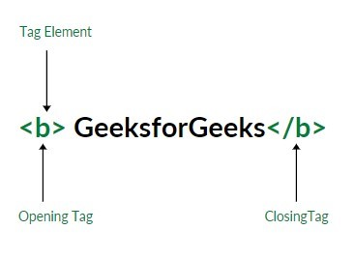
HTML PAGE STRUCTURE- The basic structure of an
HTML page is laid out below. It contains the essential buildingblock elements (i.e doctype declaration, HTML, head, title, and body elements) upon which all web pages are crated.

HTML
4. Description Of CSS
CSS - Cascading Style Sheets, fondly referred to an CSS, is a simply designed language intended to simplify the process of making web pages presentable. CSS allows you to apply styles to web pages. More importantly, CSS enables you to do this independent of the HTML that makes up each web page. It describes how a web page should look: it prescribes colors, fonts, spacing, and much more. In short, you can make your website look however you want. CSS lets developers and designers define how it behaves, including how elements are positioned in the browser.
While HTML uses tags, css use rulesets. CSS is easy to learn and understand, but it provides powerful control over the presentation of an HTML document.
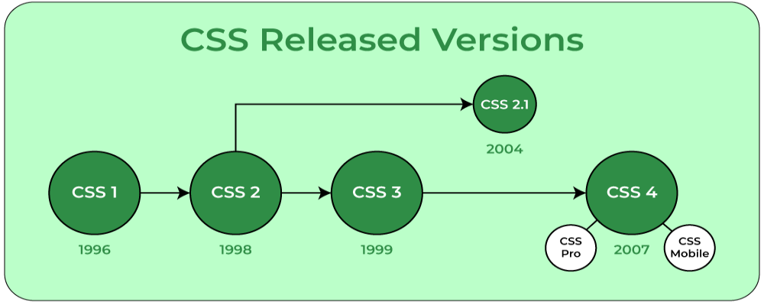

CSS SYNTAX- CSS comprises style rule that are
interpreted by the browser and then applied to the corresponding elements in your document.
A style rule set consists of a selector and declaration block.
Selector – h1
Declaration – {color: blue; font size:12px} the selector points to the HTML element you want to style.
The declaration block contains one or more declarations separated by semicolons.
Each declaration includes a CSS property name and a value, separated by a colon.
For example- color is property and blue is value.
Font-size is property and 12px is value.
CSS declaration always ends with a semicolon, and declaration block are surrounded by curly braces.

5. DESCRIPTION OF JAVASCRIPT
JAVASCRIPT – JAVASCRIPT is the world’s most popular lightweight, interpreted compiled programming language. It is also known as scripting language for web pages. It can be used for client-side as well as server-side developments.
JAVASCRIPT can be added to your HTML file in two ways:
- INTERNAL JAVASCRIPT – We can add JAVACSRIPT code directly to your HTML file by writing the code inside the <script> tag. The <script> tag can either be placed inside the <head> or the <body> tag according to the requirement.
- EXTERNAL JAVASCRIPT FILE – We can create a file with.js extension and paste the JAVASCRIPT code inside it. After creating the file, add this file in <script src= ”file_name.js”> tag inside <head> tag of the HTML file.

SYNTAX- <script>
// JAVASCRIPT code
</script>
Example – its is the basic example of JAVASCRIPT code embedded in HTML file.

CHAPTER 4
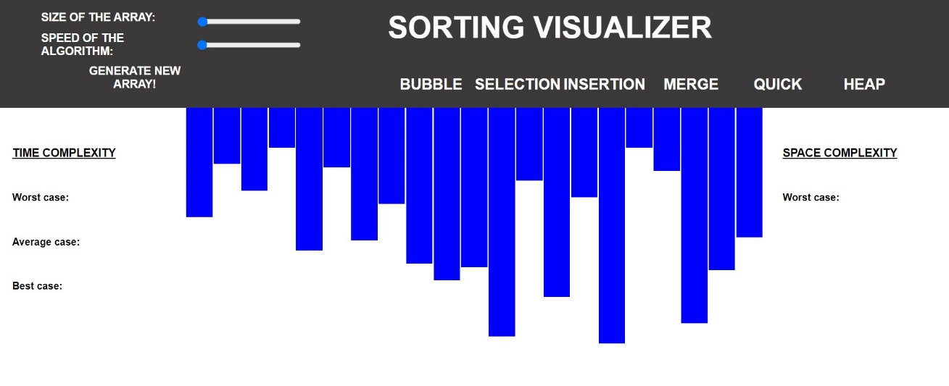
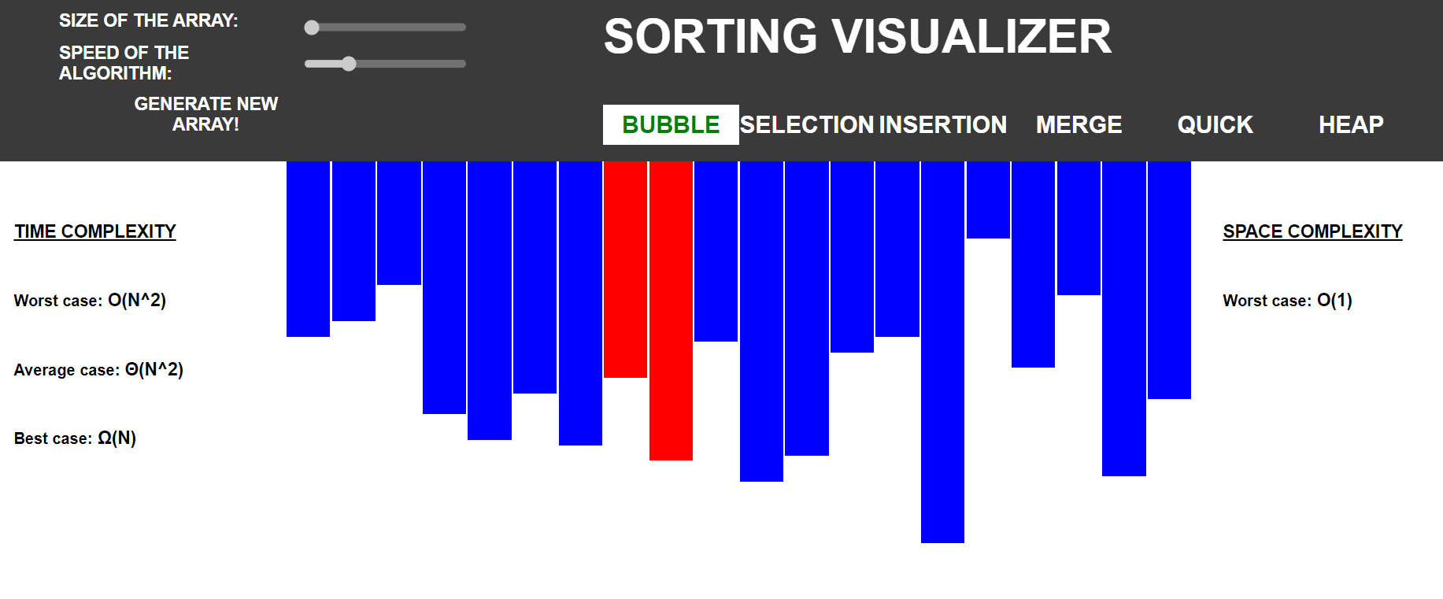
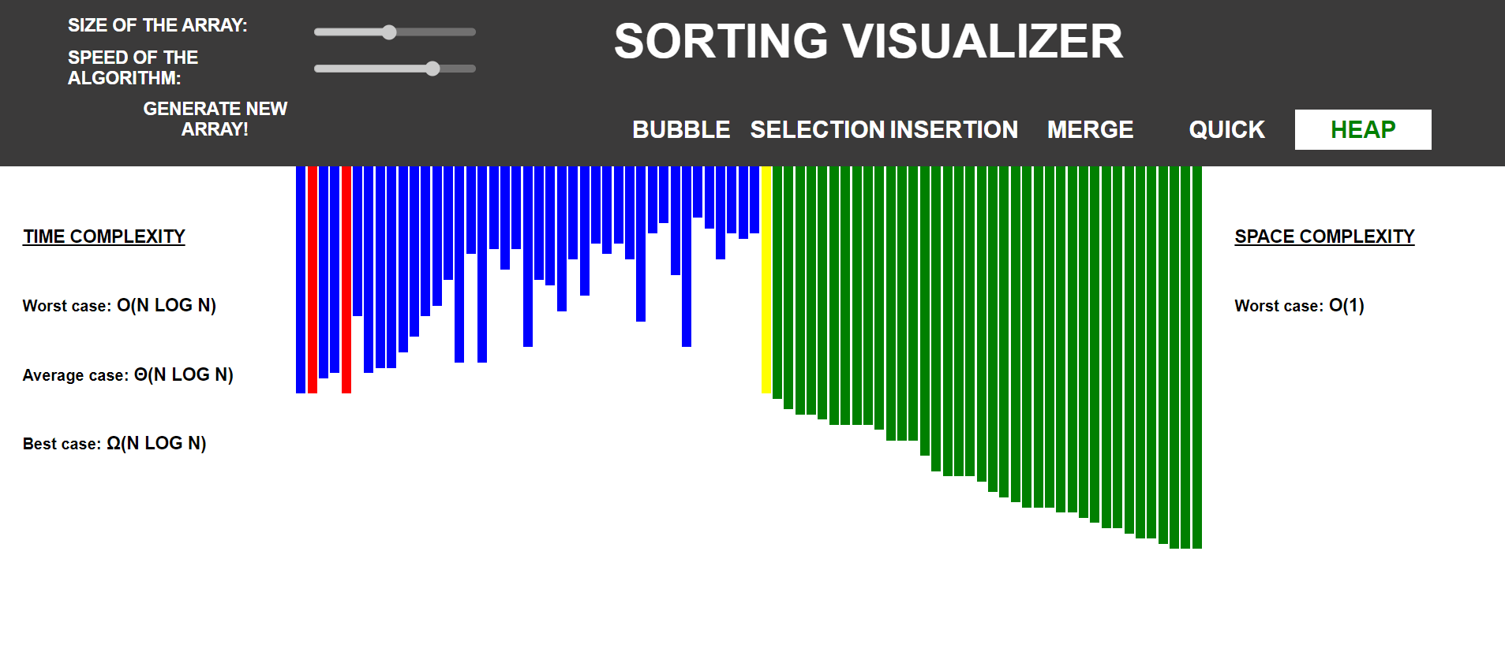
SOME SCREENS


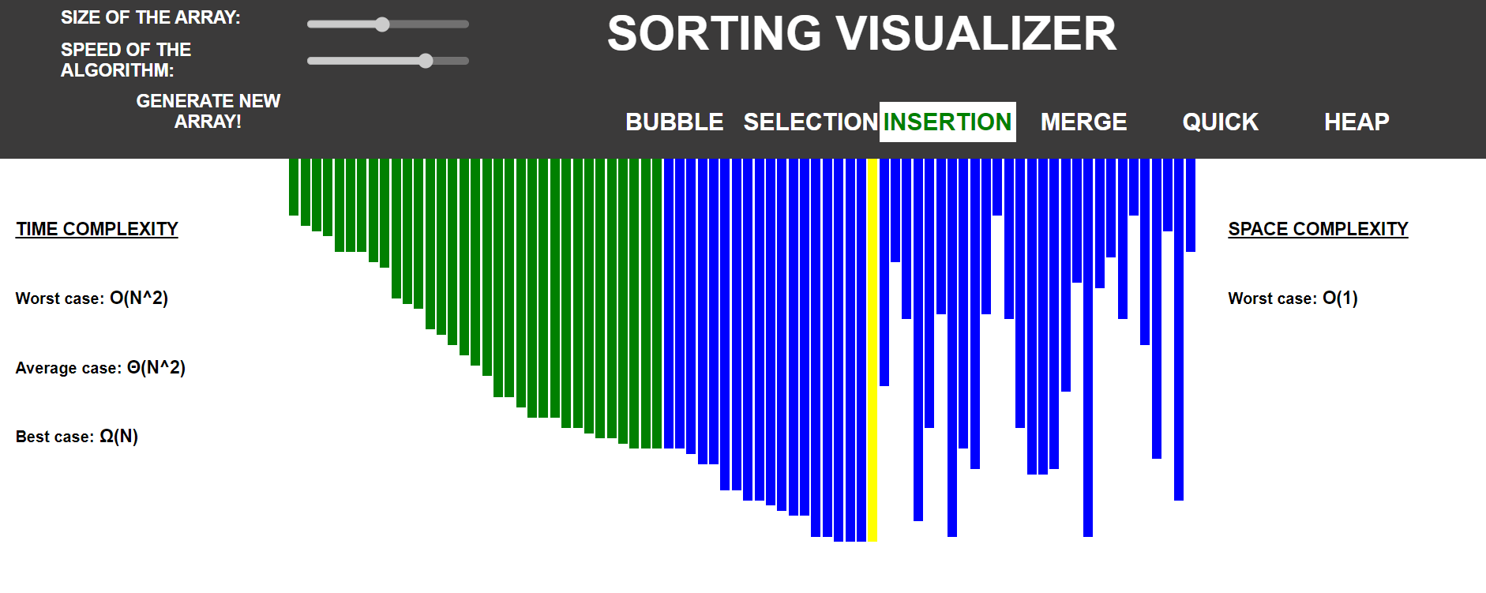
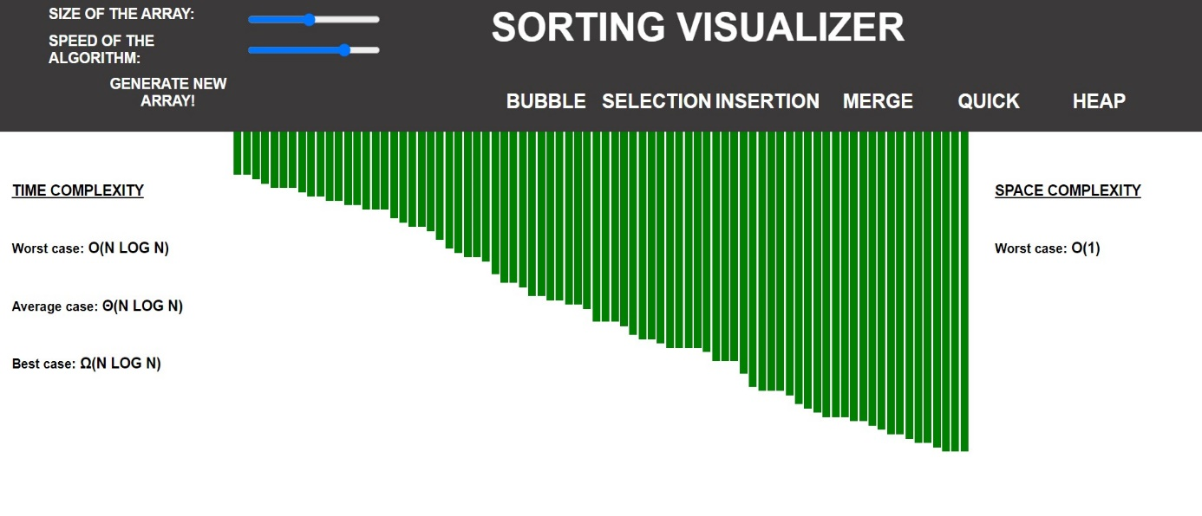

Appendices
Implementation Code
The Main Page
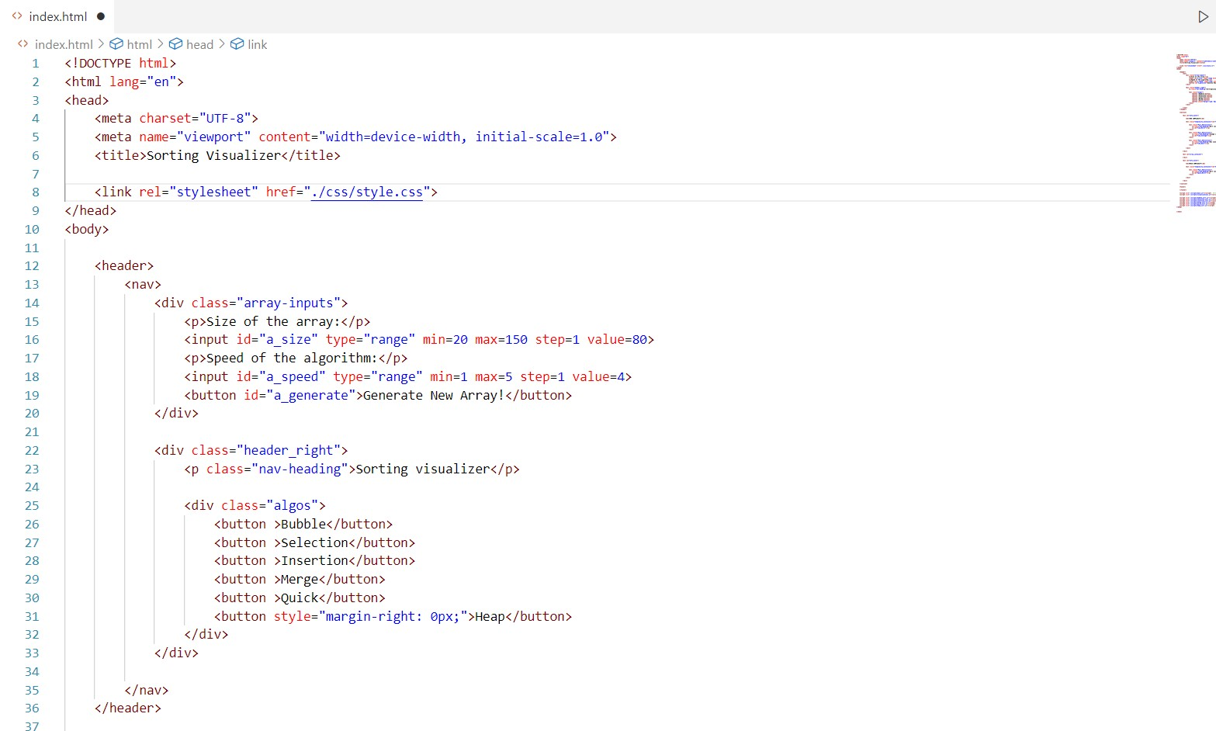
Html

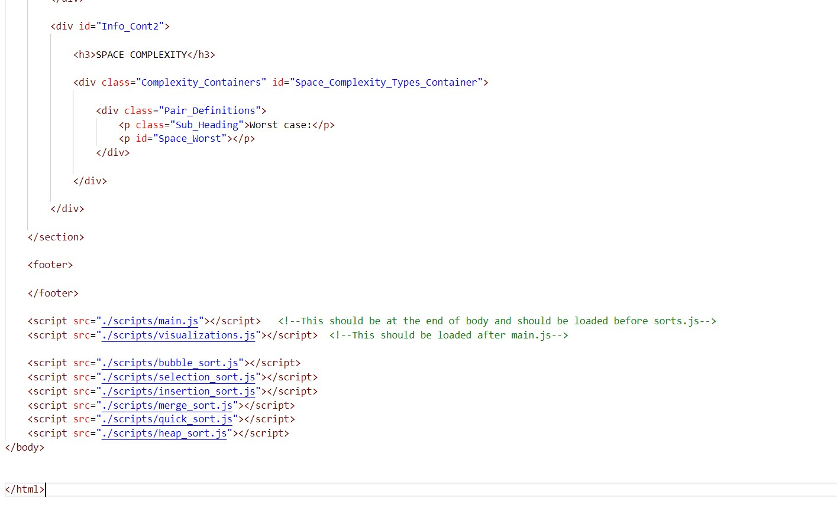
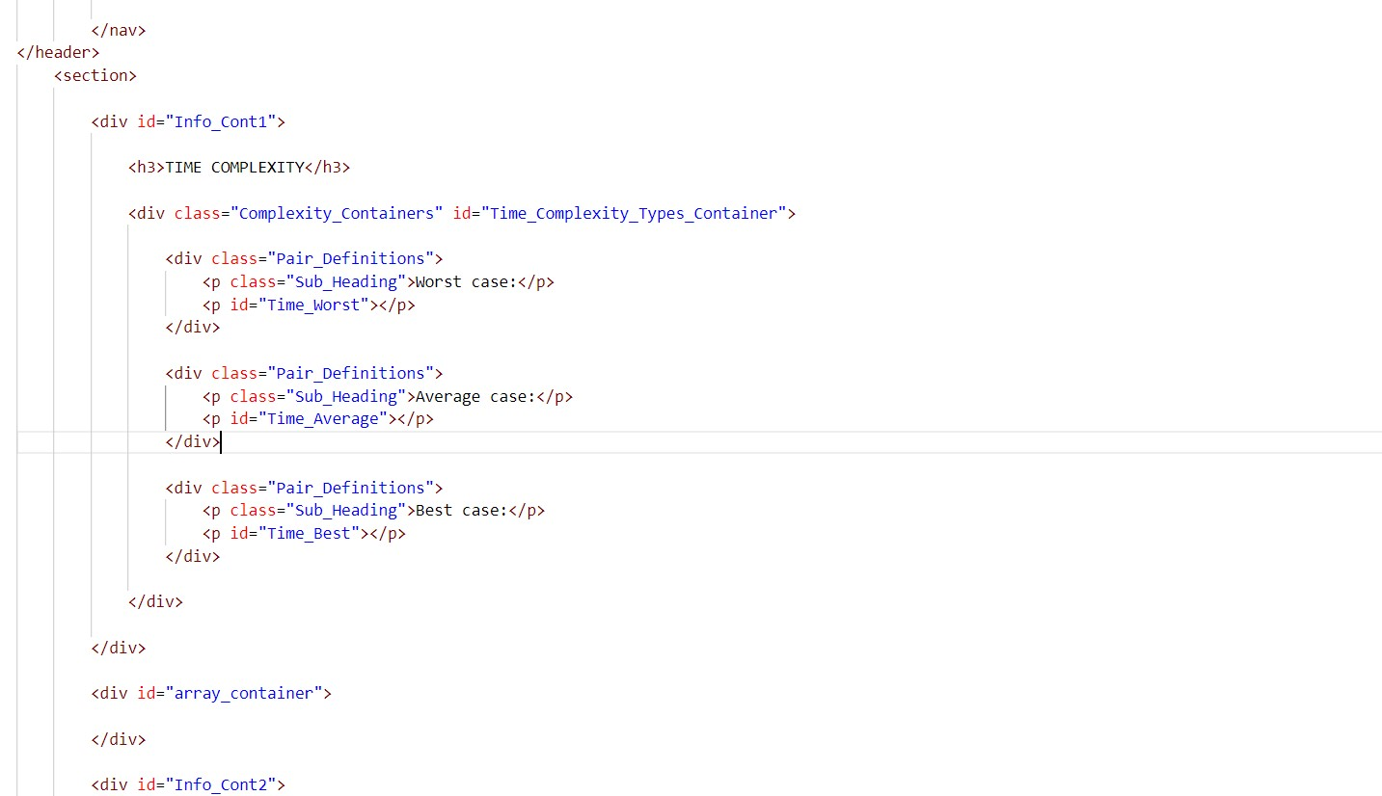

Sorting Algorithm
Bubble Sort
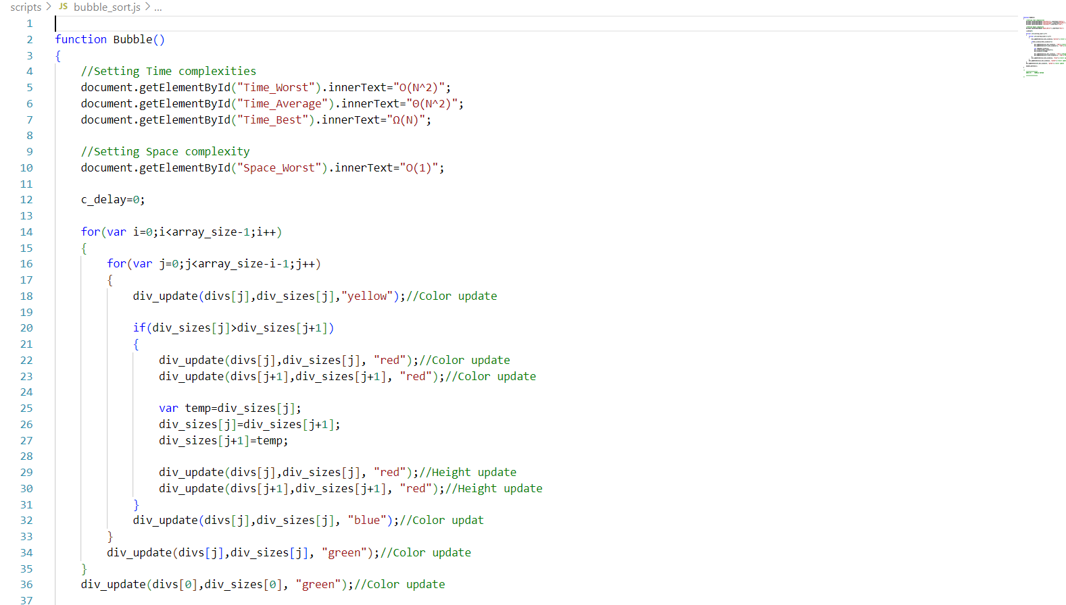

Insertion Sort
